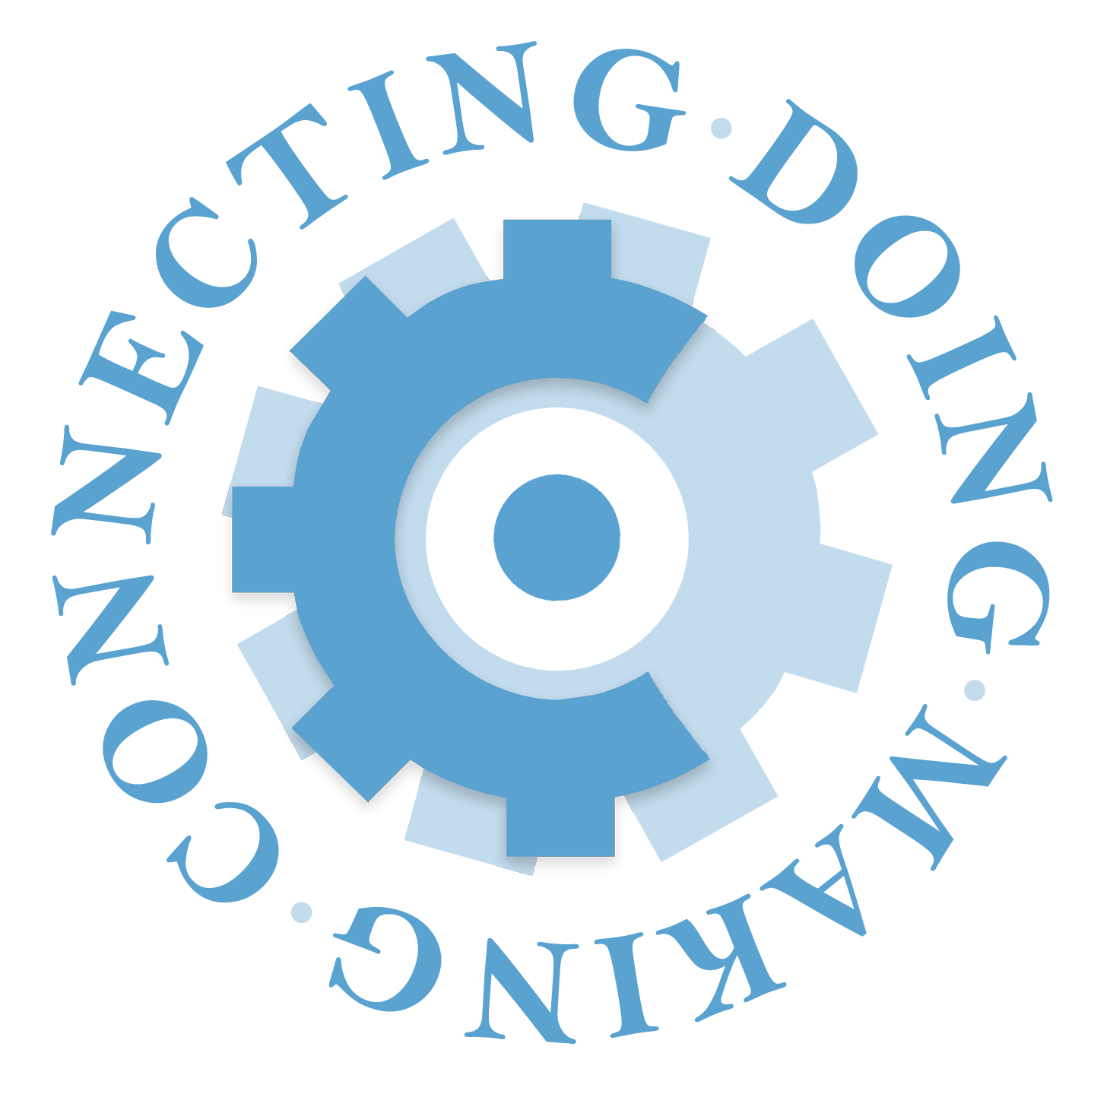
QEP Request for Proposals for Participation in Interdisciplinary Faculty Learning Community for CURE course development

Due Date: January 17, 2020

We are excited to announce a program aimed at encouraging faculty to bring course-based research experiences (CURE) into the undergraduate curriculum. A CURE is a research-intensive course based almost entirely on active student research. Students enrolled in a CURE will learn the importance of collaboration, discovery and iteration in the research process and receive experiential education credit. CURE courses fit well with the general education IDEAs curriculum that all students will have one Research and Discovery experience before they graduate. Departments can provide research experiences for more students in these courses, compared to one-on-one mentored research. Courses can be developed for a range of students, such as first-year, non-majors or for experienced capstone students.

As part of the 2017 Quality Enhancement Plan (QEP), competitive funds will be available for faculty across the College of Arts & Sciences to enhance existing courses or develop new courses that align with the CURE model. Recipients of the funds will:
- Participate in a year-long Interdisciplinary Faculty Learning Community (FLC) facilitated by other faculty teaching existing CUREs.
- Receive guidance as they develop or enhance a course. See previous course descriptions and sample syllabi here.

Timeline
Friday, January 17, 2020: Applications due by 5 p.m.
Friday, February 7, 2020: Recipients notified
Spring 2020: Introductory meeting for grant recipients
Fall 2020-Spring 2021: FLC participation and course development/enhancement

Characteristics of CUREs
A whole class working on a research question or solving a problem is the basis of a CURE. Within this process students have the opportunity to:

- Advance our knowledge around thematic research areas by asking novel questions that neither the student nor the professor know the answer to.
- Make an impact beyond the classroom through broadly relevant work that may lead to community reports or publications.
- Develop techniques/analytical skills related to research (such as gathering and analyzing data, building and evaluating models, using statistical methods or using specific instrumentation).
- Experience how ideas are built through iteration, increase their tolerance for obstacles/failure and develop resilience.
- Work collaboratively as members of a team, learn from one another and engage in peer feedback.
- Evaluate and communicate information.
- Develop a sense of belonging and project ownership.

(Refer to http://www.lifescied.org/content/13/1/29.full for more descriptions of CURE classes. Please be sure to match your proposal to CURE characteristics)

Instructor Eligibility
Full-time faculty members and lab directors in all academic units are eligible to apply. They must also be listed as the instructor of record for a course they are developing or enhancing and will be required to teach the course at least once by the end of Fall 2021. The course should then be taught at least once a year (fall, spring or summer sessions). Applicants need not have prior experience with CURE courses, and instructors with all levels of experience are encouraged to apply. Instructors may apply in pairs for shared projects.

Awards
Accepted applicants will receive $5,000 for course development and Faculty Learning Community participation. This award of $5,000 may be split between two instructors working on a joint proposal. Faculty can apply for additional funds for supplies, graduate research consultants (GRCs), instrumentation, software and related expenses when the course is taught in the first and additional semesters.

Faculty Learning Communities (FLCs)
Award recipients will take part in regularly scheduled FLC meetings. These meetings will allow faculty from all disciplines to share ideas, problems and solutions around the development and/or implementation of their CURE. The FLCs will meet monthly over a calendar year. Recipients will also participate in faculty surveys and interviews, and facilitate documentation of student projects and minimal student surveys regarding the project’s efficacy.

How to Apply
Proposals will be reviewed by a committee of faculty and staff members. Applicants are encouraged to reach out to Kelly_Hogan@unc.edu for advice/consultation about their project. Example projects are listed at http://qep.unc.edu. The proposal should include:

- A course description that will be accessible to prospective students and will get them excited about enrolling in your course (this is for the QEP website and is not an official bulletin course description.)
- A signed letter or memo from your department chair 1) endorsing the significance of the course idea 2) the plan to offer it at least once by the end of Fall 2021 and at least once a year after development 3) the willingness to support course supplies needed after QEP funds are no longer available. (We also encourage a discussion about the course scheduling, as many faculty who teach CUREs feel they work better in a longer class session).

- A brief narrative of ~ 1,500 words that includes
  - A description of the course being developed or enhanced.
  - Student enrollment: class size, whether it meets General Education or academic major requirements, etc.
  - Project’s significance within a course/curriculum.
  - Scope/ambition of the proposed plan.
  - Specific characteristics of the CURE. The committee will be looking for significant alignment with the characteristics of a CURE.
    - What novel questions will students answer?
    - How is this work broadly relevant, and what kinds of communication, reports or publications might the work lead to?
    - What specific analytical and technical skills will students learn?
    - How will students experience iteration? Are there opportunities to fail, learn, and try again?
    - What opportunities will there be for collaboration and peer feedback?
    - Describe student ownership of the project.

- A statement of feasibility
  - Feasibility of proposal implementation within the stated timeframe.
  - Project sustainability beyond the initial offering.
  - Any experience you may have with teaching students to do research that will help contribute to the success of this project.
  - A budget and description of funds needed for the first semester and in future semesters. Please note if any graduate research consultants (GRCs) through the Office for Undergraduate Research are being requested.

- Signed letter acknowledging the following responsibilities:
- “I will participate in a faculty learning community (FLC) that will meet monthly over the 2020-2021 academic year to share ideas, problems and solutions with colleagues and professional staff related to the development and implementation of CURE courses. I will build the structural components of my course over the year and bring components to the meetings to discuss. I will be prepared for meetings, which may include having completed readings or preparing documents related to my course.
- At the end of the FLC, I will receive my stipend when I can demonstrate I have significantly built the structural components of my course.
- I will participate in assessment activities, including: surveys/interviews/focus groups about my experience with the learning community; facilitating student surveys about their experience with CUREs; and permitting student work to be evaluated by external reviewers. In addition, I am willing to share what I have learned with faculty in a future FLC or seminar.
- I will have my students participate in the student exposition showcasing their discoveries at the end of each semester.”

Proposals must be submitted by 5 p.m. Friday, January 17, 2020 as a single .pdf attached to an email to QEP Director Kelly_Hogan@unc.edu.

